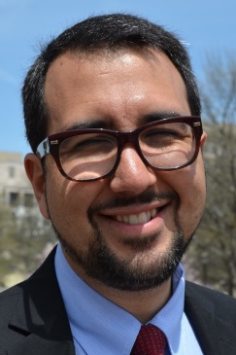

Daniel Fuster

Chief, Talent Management Division, HR Department, IDB

Mr. Daniel Fuster is the Chief of the Talent Management Division (HRD/TLM) of the Human Resources Department of the Inter-Development Bank since May 2016.
Mr. Fuster, a citizen of Costa Rica, has a Degree in Law from the University of Costa Rica, a post-graduate degree in Labor Law from the University of Valencia in Spain and a Certificate Degree in Business Administration from Georgetown University. He joined the IDB in 2008 and previous to his current post has worked as litigating lawyer in his country of origin and at the IDB has been Employment Relations Specialist, HR Business Partner, and Advisor to the Vice-President of Finance and Administration.

Rocío Palafox

Chief Finance and Administration Officer, IIC

Ms. Rocio Palafox, a national of Mexico, has been IIC's Chief Finance and Administration Officer since January 2016. Prior to joining IIC, Rocio was responsible for driving the growth of GE in Mexico, through growth initiatives, structured and financed energy and healthcare projects.
Rocio joined GE Capital Mexico in 1994 serving first as Tax Leader and then joined the GE Capital Real Estate team in 1998 serving in several leadership roles including Chief Financial Officer.
In 2011, Rocio was promoted to Chief Financial Officer of GE México, Central America and the Caribbean, where she led the formation of the share service center for Latin America and was responsible for compliance with local accounting requirements as well as to promote the hiring and retention of talent from the financial sector.
Prior to joining GE Capital, Rocio worked in a Tax Advisory firm in Mexico City and was University Teacher at the ITAM.
She earned a BA in Public Accounting (CPA) from the Instituto Tecnológico Autónomo de México (ITAM).

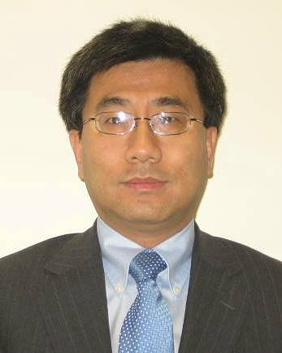

Jianjun Xu （徐建军）

Senior Specialist, Office of Outreach and Partnerships, IDB

Mr. Jianjun Xu has been Operations Senior Specialist at Office of Outreach and Partnerships of IDB since August, 2015. His work focuses on managing partnerships between IDB and China.
Prior to joining IDB, Mr. Xu had extensive working experience with the People’s Bank of China (PBC) on the area of international finance and international organizations, where he held various positions, including Director of MDBs Division at International Department of PBC, Coordinator for China Co-financing Fund for Latin America and the Caribbean at IDB, Chinese Counselor at Board of Executive Directors of IDB, Chinese Advisor at Board of Executive Directors of IMF, and Executive Director of the Eastern and Southern African Trade and Development Bank (PTA Bank) for China.
Mr. Xu holds Master degrees in Economics and Economics of Development from Renmin University of China and the Australian National University, and Bachelor degree in Applied Mathematics from Tongji University in Shanghai.

